**How to Generate and Set Up SSH Keys on Ubuntu**

The SSH key generation process creates two keys:

* **Public key**. Installed on the server, allows the server to recognize and [authenticate](https://phoenixnap.com/glossary/what-is-authentication) the client based on the matching private key.
* **Private key**. Must be kept secure. It is crucial for the authentication process to ensure that you are the only person who can authenticate to the server.

Follow the steps below to create the public-private key pair.

**Generate SSH Key Pair**

Generate a pair of SSH keys on the **client** system. The client system is the machine that connects to the SSH server.



1. Create a [directory](https://phoenixnap.com/glossary/what-is-a-directory) named *.ssh* in the home directory. The **-p** option ensures the system does not return an error if the directory exists:

mkdir -p $HOME/.ssh

2. [Change permissions](https://phoenixnap.com/kb/linux-file-permissions) of the directory to give the user **read**, **write**, and **execute** privileges:

chmod 0700 $HOME/.ssh

3. Execute the **ssh-keygen** command to create an [RSA](https://phoenixnap.com/glossary/rivest-shamir-adleman) key pair:

ssh-keygen

4. When prompted, provide the path to the key [file](https://phoenixnap.com/glossary/what-is-a-file). If you press **Enter** without typing a file path, the key will be stored in the *.ssh* directory under the default file name **id_rsa**.

5. The system asks you to create a passphrase as an added layer of security. Input a memorable passphrase, and press **Enter**.

The output shows that the keys have been created successfully.

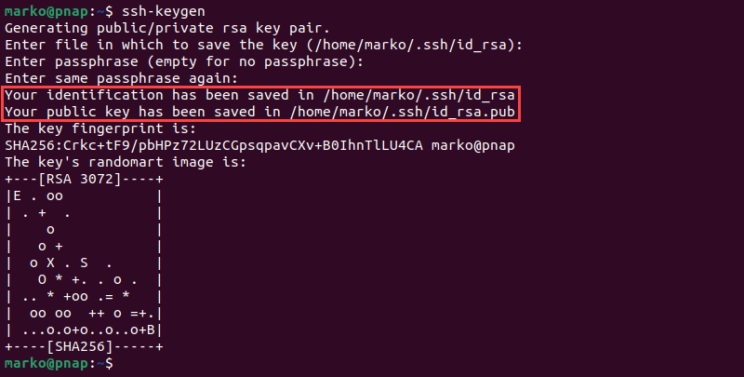

Step 6 . cat ~/.ssh/id_rsa.pub

Step 7 Click on Avatar on the gitlab page on the top right hand side and in the drop down select preferences . As shown in the screenshot:





Step 8 Select Preperences and

Step 9 Select SSH

And Step 10 Add key

Step 11 Paste the copied SSH public key content without any extra space as it is.

Here you go.